Russell E. Erbes, CCM
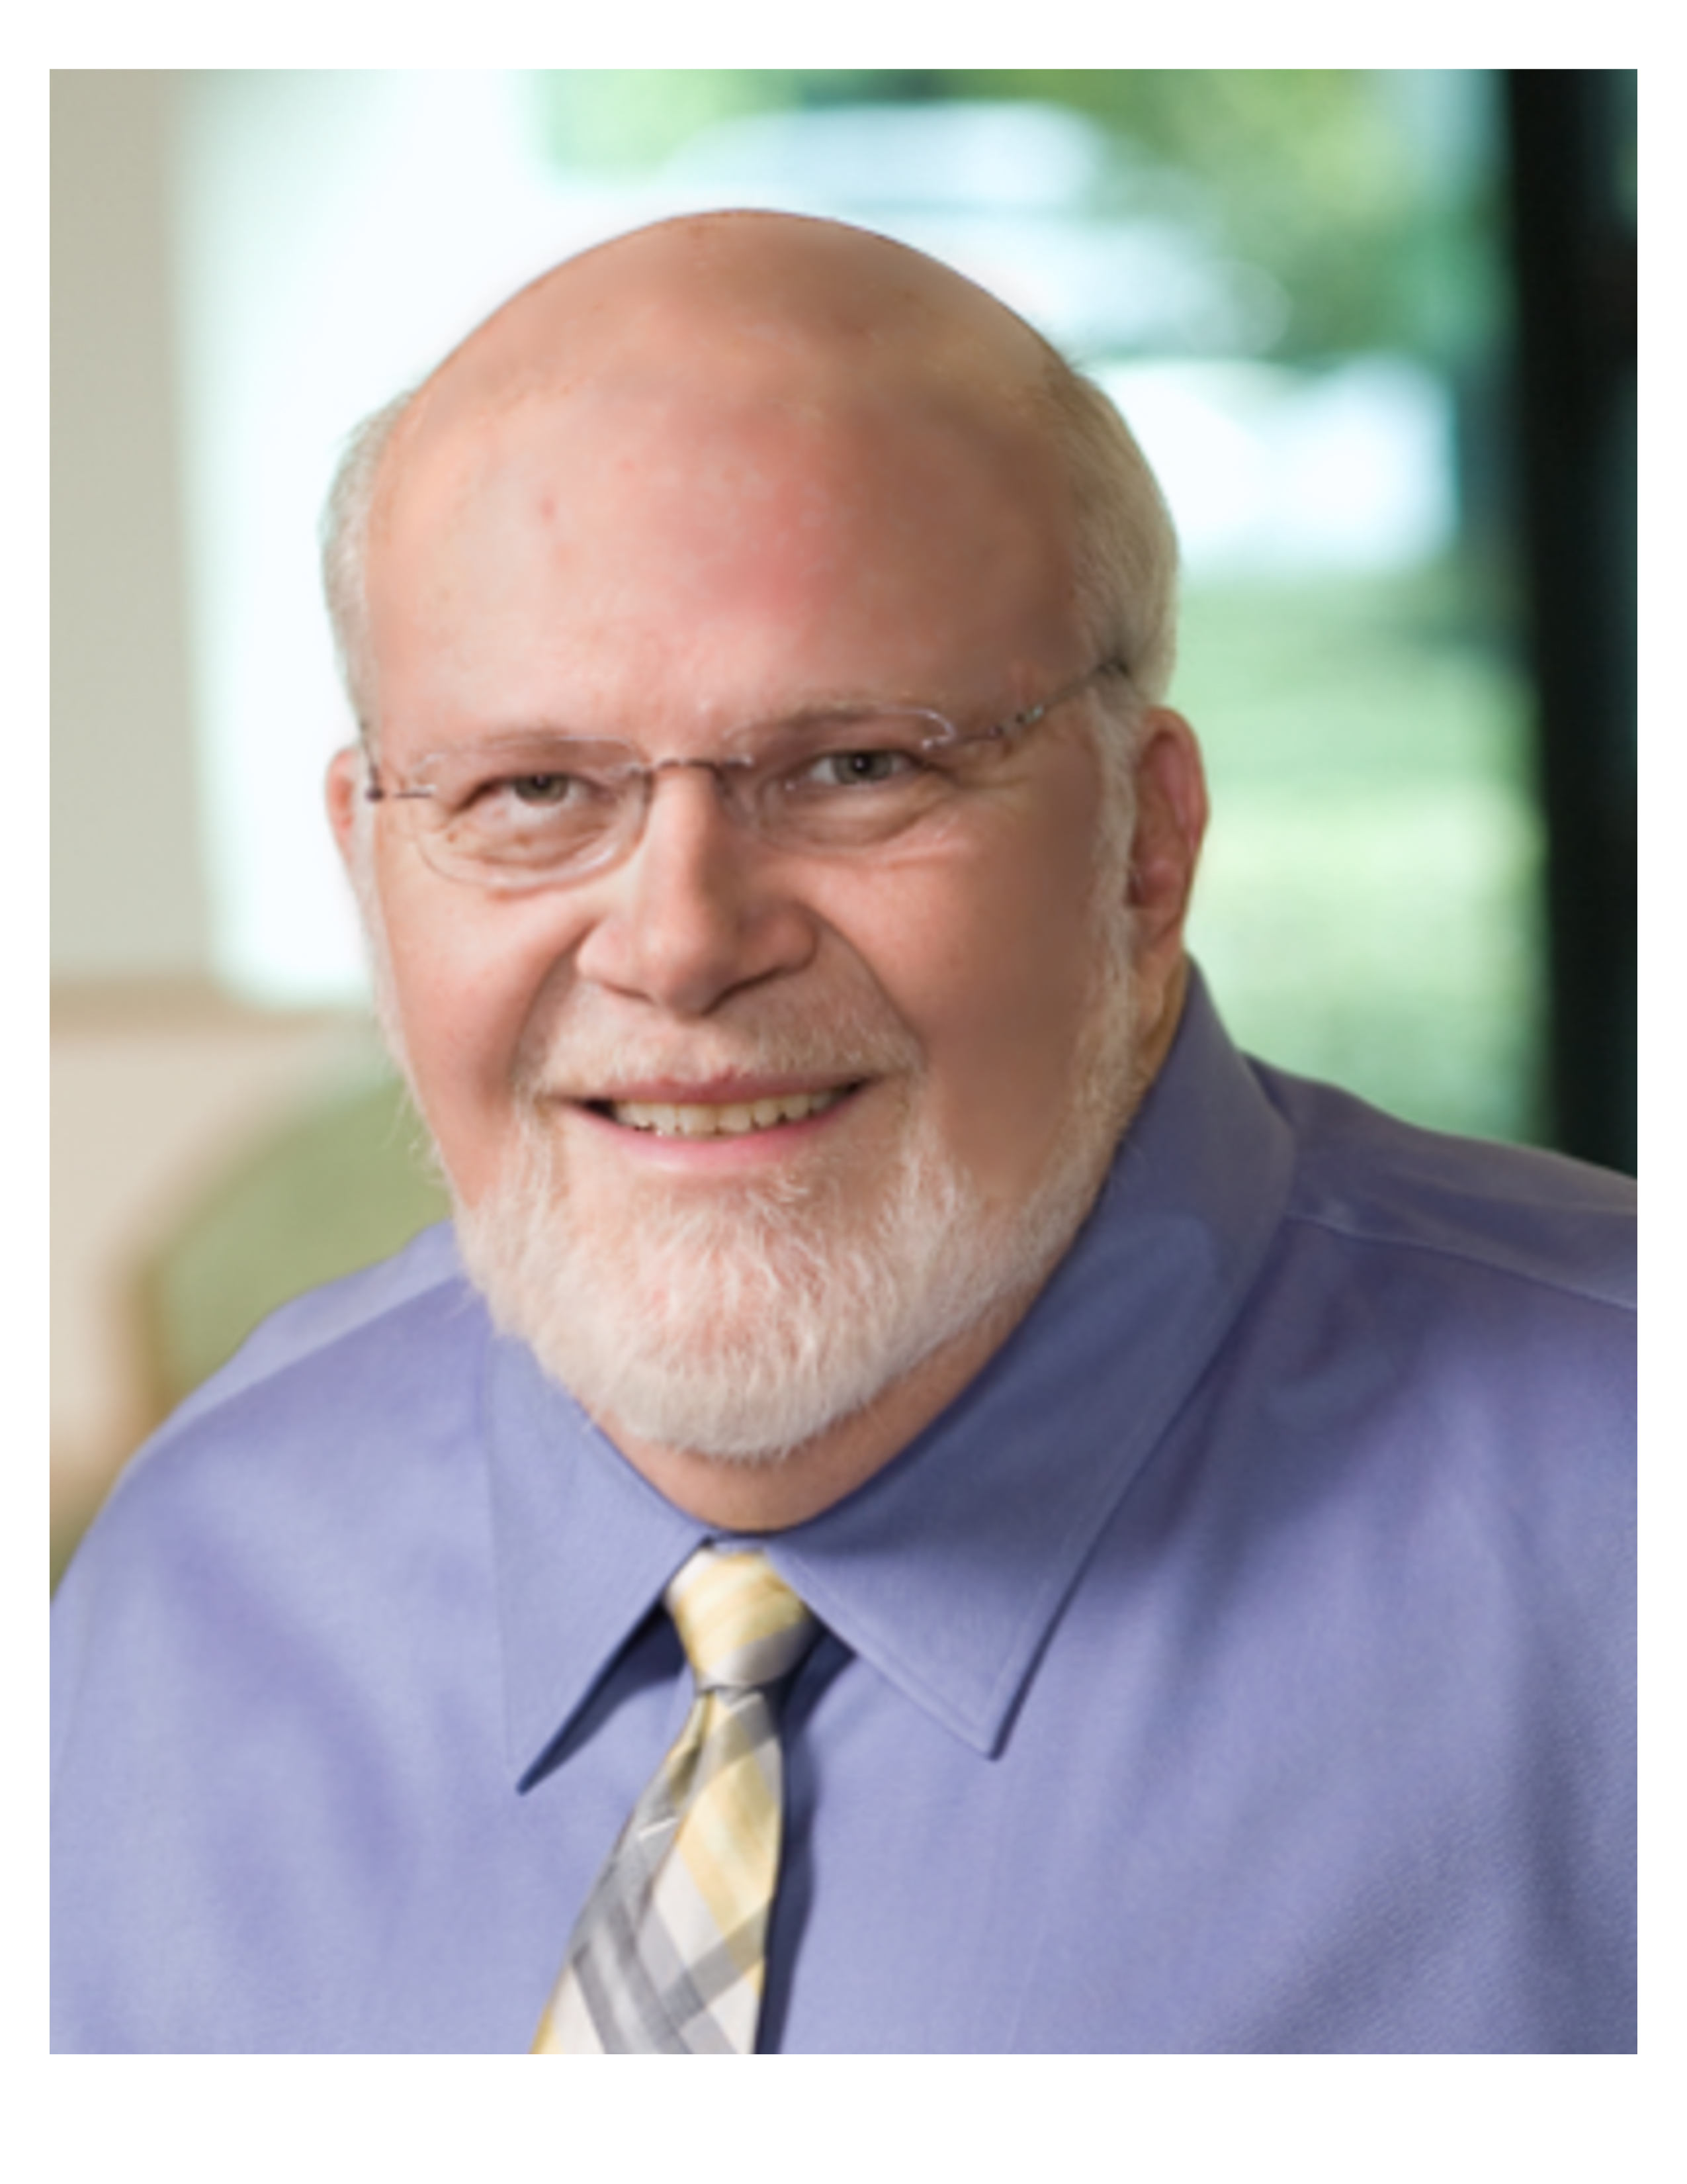
10044 Granite Hill Drive
Parker, CO 80134
+1 303 748 7190
rerbes@comcast.net

Mr. Erbes is a Certified Consulting Meteorologist, and former Chief Technical Officer (CTO) of a major science and engineering consulting firm. As CTO Mr. Erbes was responsible for developing and implementing Quality Management Programs that met a wide variety of client demands, up to and including NQA-1. He was also responsible for developing and implementing a technical development career path program for highly skilled professionals who want to advance within the firm but do not want management positions, the so-called Third Dimension of corporate organizations.

Mr. Erbes has over 40 years of consulting experience, all of which was focused on delivering high quality technical deliverables. As a practicing consulting scientist, he understands the advantages and disadvantages of Quality Management Programs as practically implemented. Also, since he personally became an executive of a major technical consulting firm through the technical career path, he understands the complexity of developing and implementing a system for professionals to advance in other than line management positions.

Mr. Erbes continues to provide air quality consulting services, is a recognized author and lecturer with numerous publications, and has presented at numerous industry and client-based forums. He is author of the hardcover book A Practical Guide to Air Quality Compliance, Second Edition, published by John Wiley & Sons.

WORK HISTORY

2013-present Practical Enterprise Solutions, LLC / WWRD Consulting LLC
Chief Executive Officer and Principal Scientist
Practical Enterprise Solutions, LLC was founded to provide a wide variety of management and technical consulting services. WWRD Consulting is a dba for Practical Enterprise Solutions, focusing on air quality technical services. Services provided by Mr. Erbes include:

- Air Quality Technical Consulting Services
- Environmental Consulting Services
- Development and/or Review of Quality Management Programs
- Development and/or Review of Technical Career Path and Development Programs
- Technical Peer Reviews of Businesses

2007 - 2013 The Kleinfelder Group, Inc.
Chief Technical Officer
- Overall technical leadership of US based science and engineering consulting firm with nearly $400M in revenue, ranking in the top 40 of US A/E firms and the top 100 of all design firms globally.
- Responsible for developing and implementing a formal Quality Management Program that provided a gradational level of formalism as required by different clients up to and including NQA-1.
- Responsible for developing and implementing technical career path opportunities for advancement of firm professionals.
- Leader of the annual Technical Seminar for five years, a company-wide technical conference at which more than 100 technical papers are presented each year to nearly 1,000 attendees; including clients, teaming partners, strategic acquisitions, and company employees.

2007-2012 Kakona Captive Insurance Company
Chairman of the Board, CEO, and President
- Managed a captive insurance company that provided professional liability and general liability coverage for the parent company.
- Developed and implemented a claims reduction program for the parent company that included financial and technical support to evaluate additional safety and technical quality improvement concepts.
- Speaker at the Hawaii Captives Insurance Council Annual Educational Forum on technical loss prevention and quality management.
- Led the evaluation of additional lines of insurance coverage and vehicles for providing such coverage, including captive insurance pools.

1989-2013 The Kleinfelder Group, Inc.
Air Quality Program Director
- Built an air quality consulting practice that started in one local office and grew to cover the entire company and services.
- Coordinated air quality consulting services across all functional and geographic lines throughout the company.
- Implemented a quality management program for air quality.
- Provided technical leadership and training for air quality professionals.
- Coordinated with all local and geographic management to grow the air quality practice.

1987-1989 Geoscience Consultants Ltd.
Vice President, Program Management
- Led the Project Management line function and staff in an 85-person environmental consulting company
- Specialized in underground storage tank cleanups, hazardous waste management, contaminated soil and groundwater remediation, and air quality consulting.

1977-1987 Public Service Company of New Mexico.
Manager, Environmental Regulatory Programs
- Led an 18-person environmental department that focused on environmental regulatory compliance for a large southwestern electric utility.
- Developed and implemented environmental compliance programs for all media: air, water, and hazardous waste.
- Prepared numerous environmental impact assessments and provided expert witness testimony related to those assessments.

1975-1977 Farmington High School.
Teacher
- Mathematics and science teacher for Grades 10 through 12

1969-1975 US Navy.
Naval Flight Officer
- Combat Information Center Office (CICO) in E-2B Hawkeye, carrier-based airborne early warning and flight control platform.
- NATOPS (quality, accident and loss prevention) Officer
- Legal Officer
- Public Affairs Officer

EDUCATION

1978 Colorado State University
Master of Science Degree

- MS in Atmospheric Science
- Specialty in Cloud Physics

1965-1969 New Mexico Institute of Mining and Technology
Bachelor of Science Degree

- BS in Physics
- Specialty in thunderstorm electrification
- Elected student body President
- Winner of the Brown Medal, awarded to the student that best exhibits a combination of academic and leadership accomplishments

PERSONAL INFORMATION

Citizenship: US
Marital status: married, 12 children
Willing to travel as necessary
Other interests: Photography, woodworking

