FOR IMMEDIATE RELEASE
November 28, 2016
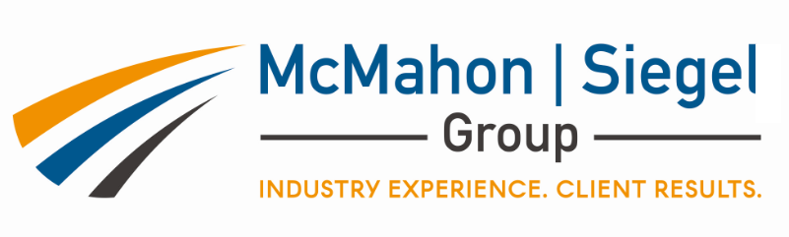

Geoprofessional Business Association (GBA) announces a partnership with McMahon|Siegel Group for new, industry leading, training and development program
GOLD: Geoprofessional Operational Leadership Development. Providing advanced business leadership education for the geoprofessional community

Colorado Springs, CO – The Geoprofessional Business Association (GBA) has teamed up with the McMahon|Siegel Group, to provide a new, industry leading, training and development program. GBA member firms will be able to exclusively participate in GOLD: Geoprofesisonal Operational Leadership Development.
Providing advanced business leadership education for the geoprofessional community, the six month course combines two, two-day, in-person sessions with modern distance learning programs to deliver a broad learning experience for all attendees. The course will be led by two veterans of the AE industry, Kevin McMahon and Bill Siegel, as well as utilize other experienced business leaders, to bring a balanced focus of theory and practice, including training in real world operations/leadership not currently available in the marketplace.

The program will combine leadership and personal development training with specific instruction in operational aspects of the typical Geoprofessional business. Covered topics will include:

- Demystifying Financial statements
- Understanding the blueprint for financial success
- Building on your individual strengths
- Creating a system of communication and performance
- Risk management, liabilities and contract challenges
- Markets, marketing and clients
- Building and maintaining a successful team
The target demographic for this program is a new or emerging leaders, and existing or potential managers of geographic locations or business units. Anyone with a desire to learn more on how to build and run a successful and profitable consulting business would benefit from attendance in this program.
The first class will start in the fall of 2017. For more information and registration please contact GBA or info@mcmahonsiegelgroup.com

